PROJECT DESIGN PHASE
Proposed Solution Template
Date | 06 September 2026 | Team ID | ________
Project Name | Incident Lifecycle Automation in ServiceNow | Maximum Marks | 2 Marks
Proposed Solution Template:
The project team proposes a ServiceNow-based Incident Management solution that standardizes the complete incident lifecycle, improves visibility, supports faster resolution, and strengthens SLA compliance.
S.No. | Parameter | Description
1 | Problem Statement (Problem to be solved) | Incidents reported through emails, phone calls, or informal channels can result in poor tracking, incorrect classification, delayed escalation, limited resolution visibility, SLA breaches, and weak root-cause tracking.
2 | Idea / Solution description | Automate and standardize Incident Management using ServiceNow. Service Desk agents create and classify incidents; incidents are assigned to suitable support groups; Level 2 technicians investigate and resolve them; emergency changes and child incidents can be created when required; resolved incidents can be converted into reusable knowledge articles.
3 | Novelty / Uniqueness | The solution connects incident handling with Knowledge Management, reassignment, emergency change requests, child incidents, and knowledge creation within one structured lifecycle, reducing disconnected manual activities.
4 | Social Impact / Customer Satisfaction | Faster and more transparent incident handling improves service experience. Users benefit from clearer status tracking, quicker resolution, consistent communication, and better reuse of known solutions.
5 | Business Model (Revenue Model) | The solution is intended for organizational IT service operations. Business value comes from improved productivity, reduced incident-handling effort, better SLA compliance, and more efficient use of support resources.
6 | Scalability of the Solution | The workflow can be extended across departments, support groups, services, and incident volumes. Additional automation, SLA rules, dashboards, knowledge articles, and escalation paths can be added as organizational needs grow.
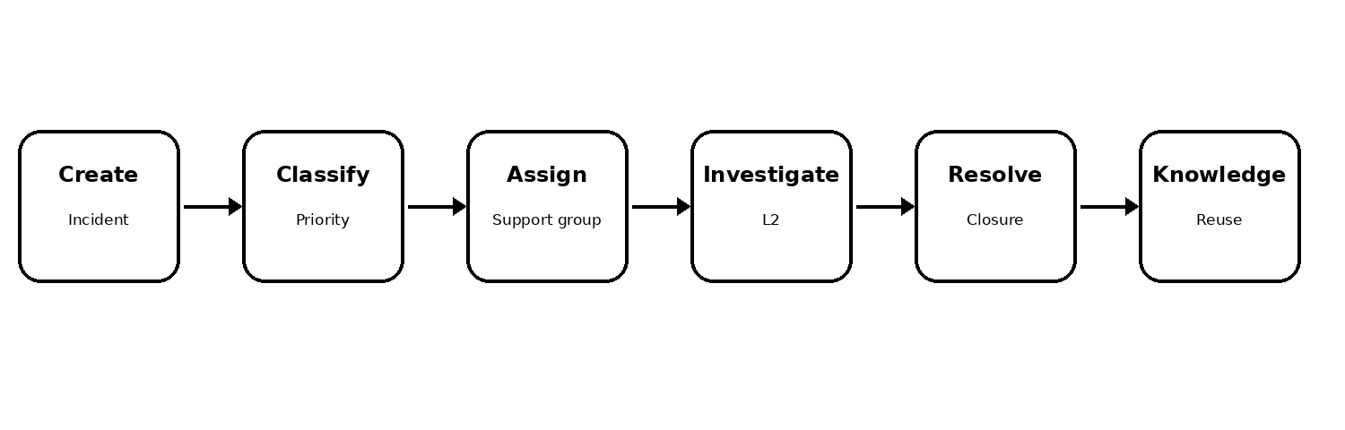
Figure 1. Proposed ServiceNow Incident Lifecycle

SOLUTION WORKFLOW & EXPECTED OUTCOME
How the Proposed Solution Works
• Incident Creation – Service Desk agents record incidents with relevant details.
• Classification & Assignment – Incidents are categorized, prioritized, and routed to the appropriate support group.
• L2 Investigation – Level 2 technicians investigate the issue, update work notes, and apply the required resolution.
• Change & Child Incident Handling – Emergency change requests can be initiated from incidents, and child incidents can track related or recurring issues.
• Knowledge & Closure – Resolved incidents can support knowledge article creation, while final closure records the resolution and SLA outcome.
Expected Outcomes
• Centralized incident tracking and improved service visibility.
• Faster resolution through Knowledge Management and solution reuse.
• Better escalation, reassignment, and collaboration across support levels.
• Improved SLA compliance and reduced risk of delayed resolution.
• Reusable knowledge captured from successful incident resolutions.
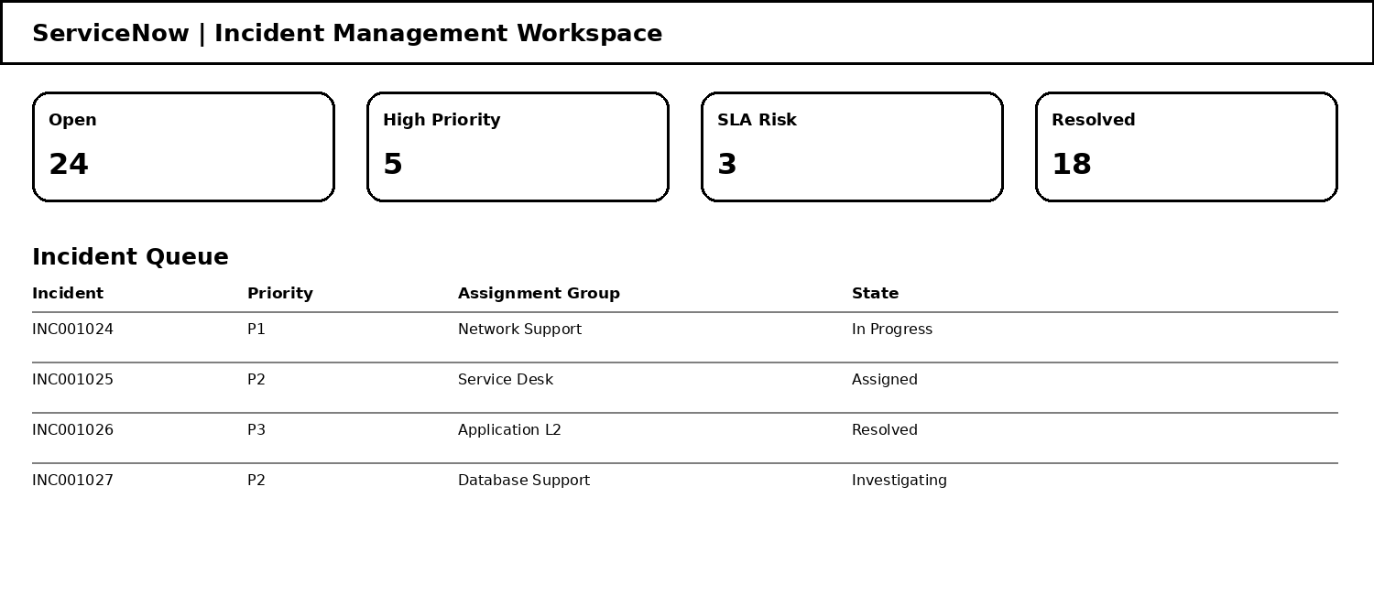
Figure 2. Illustrative ServiceNow Incident Management workspace
References
1. Provided Incident Lifecycle Automation in ServiceNow requirements.
2. Provided Proposed Solution Template.

